Name: **Sahil Dattatray Mohite**

Roll No: **30** Batch: **B2**

PRN: 12010501

Lab Assignment 4

**Accept 5 numbers and display the count of positive and negative numbers.**

In 8 bit numbers

00 to 7F (127) 🡪 positive numbers

80 (128) to FF (255) 🡪 negative number

For signed binary numbers the most significant bit (MSB) is used as the sign bit. If the sign bit is “0”, this means the number is positive in value. If the sign bit is “1”, then the number is negative in value

Positive Signed Binary Numbers

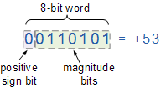

Negative Signed Binary Numbers



